Implementation of DBMS Exercise Sheet 14 Km., WS 2024 / 2025

Q1a:

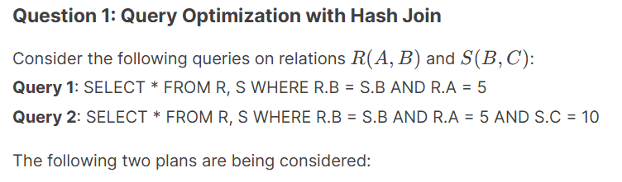

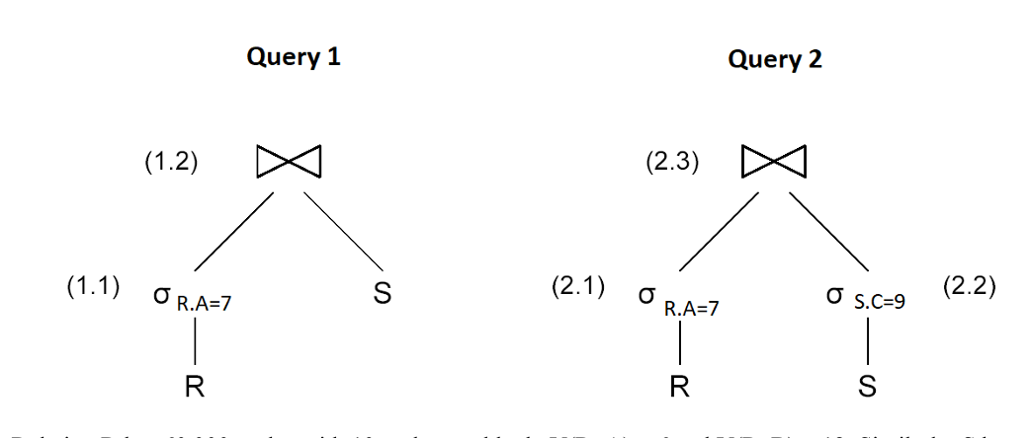

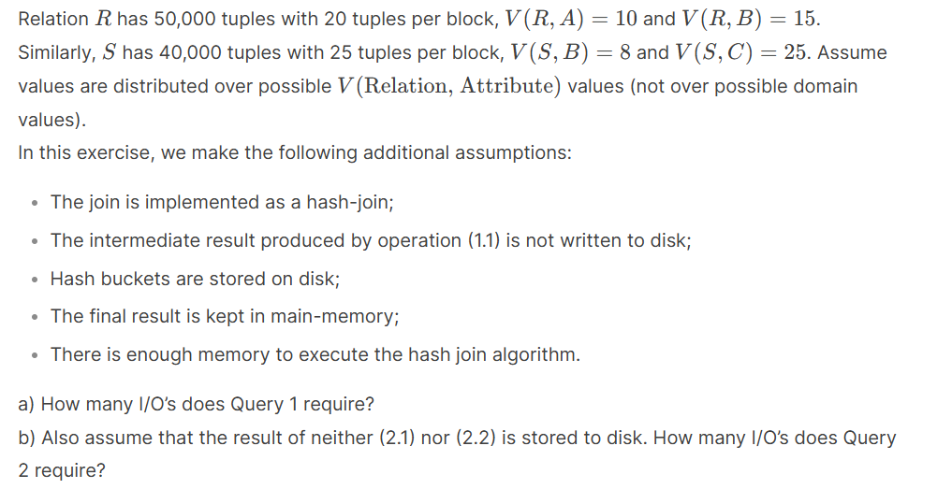
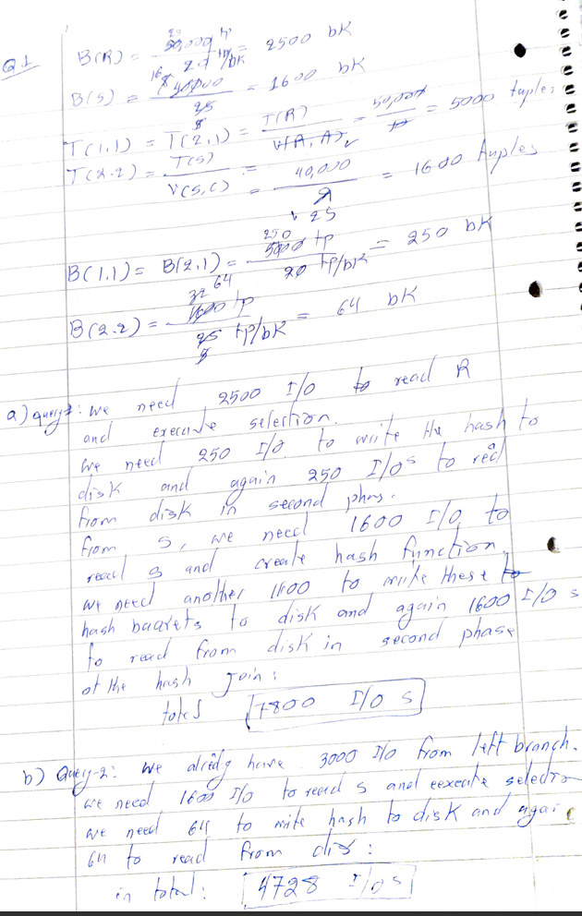

Question 1b: Query Optimization with Hash Join

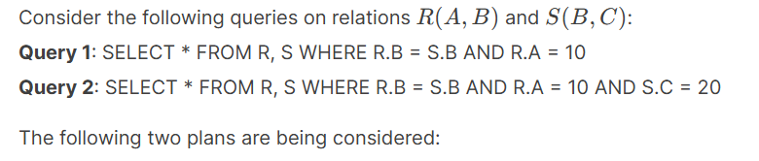

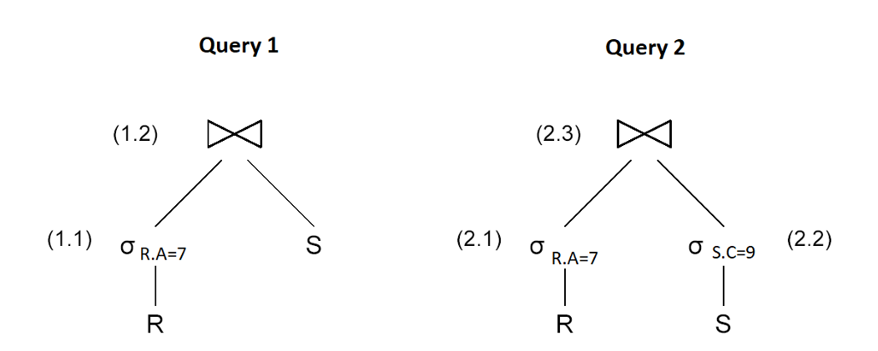

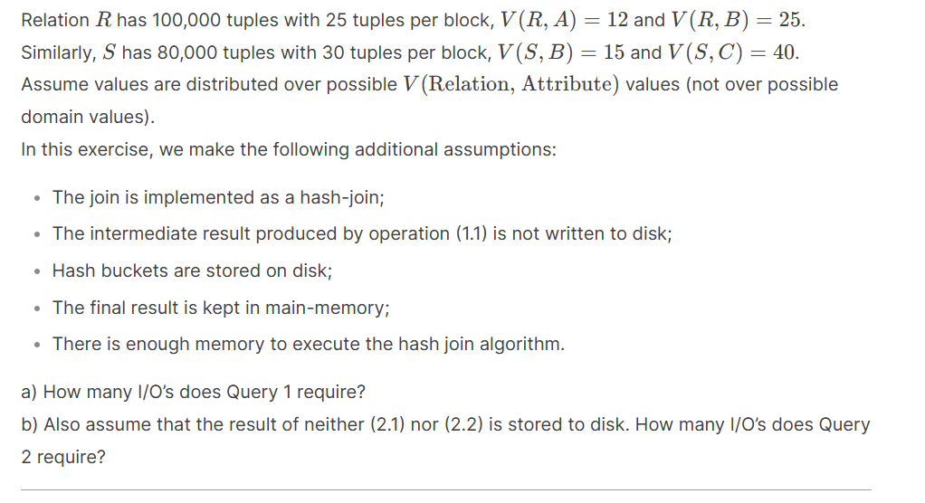
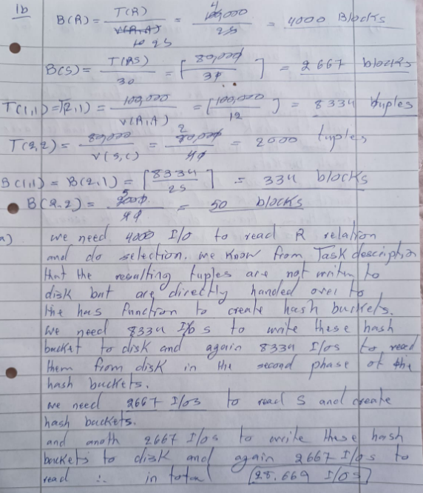
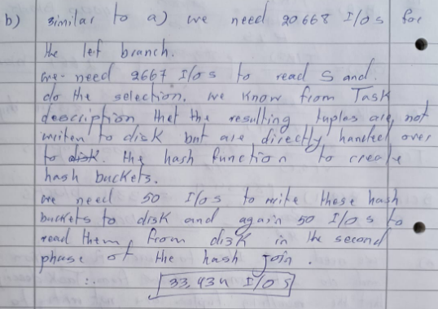

Question 1c: Query Optimization with Different Selectivity

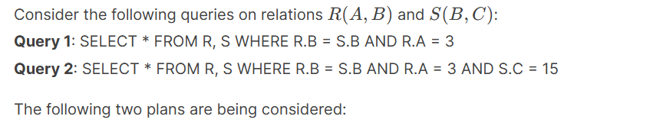

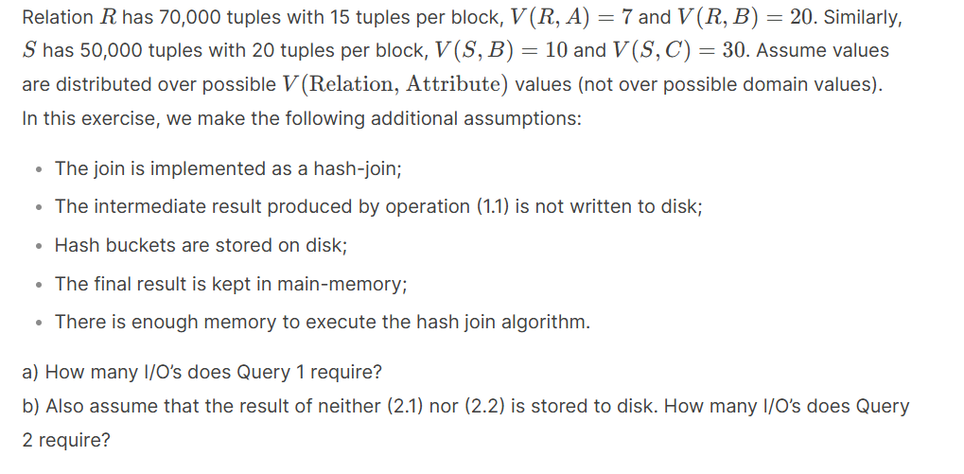

Question 2a)
Suppose we have two relations A and B with the following properties:
- B(A) = 30,000, B(B) = 60,000, The number of available main memory blocks is M = 150
- Both relations are clustered but unsorted
We want to perform a merge join on A and B using the available memory.

Questions:
a) How many sorting passes are required before the merge phase?
b) Describe how the merge join is executed and compute the total I/O cost.

Question 2b)
Consider two relations T(X, Y) and U(Y, Z):
- B(T) = 25,000, B(U) = 75,000, M = 120 main memory blocks are available
- Both relations are clustered but not sorted
We aim to join T and U on T.Y = U.Y using the merge join algorithm.

Questions:
a) Determine the number of passes required to sort each relation before merging.
b) Explain the execution of the merge join and calculate the total I/O cost.

Question 2c)
Given the relations R(A, B) and S(B, C): B(R) = 50,000, B(S) = 90,000M = 200 main memory blocks
- Both relations are clustered but initially unsorted, We need to perform a merge join on R and S.

Questions:
a) Compute the number of sorting passes needed before merging.
b) Describe the merge join execution and determine the I/O cost.

✅ These two exercises (3a, 3b) mirror exactly the query optimization comparison style of Exercise 3.
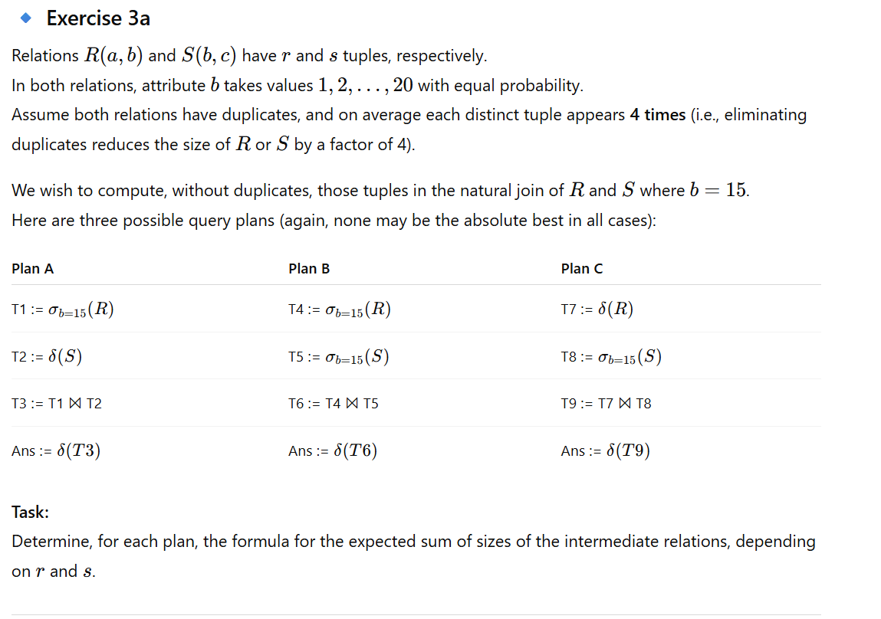

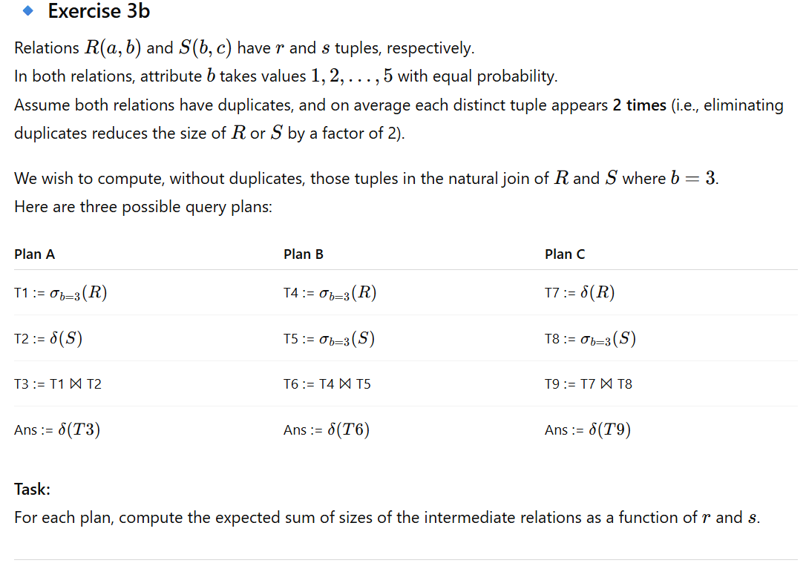
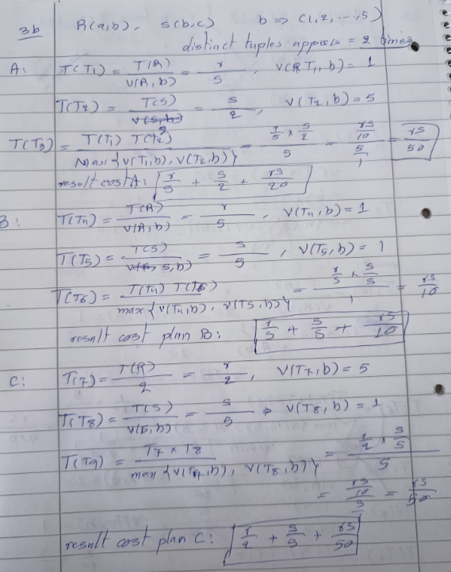
4a)
Consider two relations R(A, B) and S(B, C) with sizes B(R) = 30,000 and B(S) = 40,000 blocks, respectively. The available main memory has M = 150 blocks. We want to perform a one-pass join between R and S.
a) How many memory blocks are required to perform the join in a single pass?
b) If one-pass join is not feasible, what would be the best alternative join method given the memory constraints?

4b)
Given two relations R(X, Y) and S(Y, Z) stored in B(R) = 10,000 and B(S) = 20,000 blocks, we have M = 250 main memory blocks available. Both relations are unsorted and unclustered.
a) Can we perform a one-pass join with the given memory?
b) If not, how many passes would a two-pass sort-merge join require, and what would be the estimated I/O cost?

Question 4c:

Suppose we have two relations R(P, Q) and S(Q, R) stored in B(R) = 50,000 and B(S) = 80,000 blocks. The main memory available for the join operation is M = 300 blocks.
a) What is the minimum number of memory blocks required to perform a one-pass hash join?
b) If we were to use a partitioned hash join, how many partitions would be required, and how would they be distributed across memory?

Question 5:
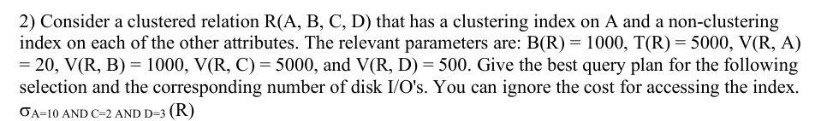

Question 5a:
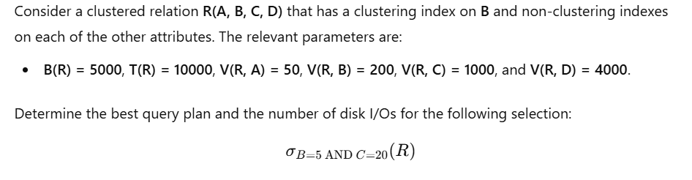

Question 5b:
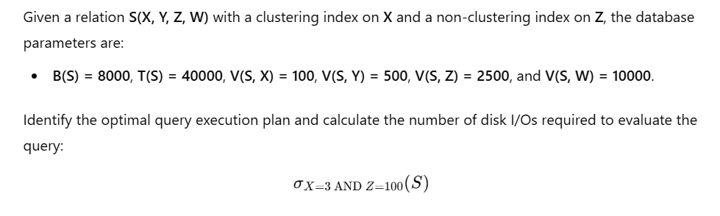

Question 5c:
